Day 1

HTML, CSS & SASS/SCSS

HTML: Hyper Text Markup Language - Display the content

CSS - Cascading Style Sheet - Style

HTML file

Lists & headings

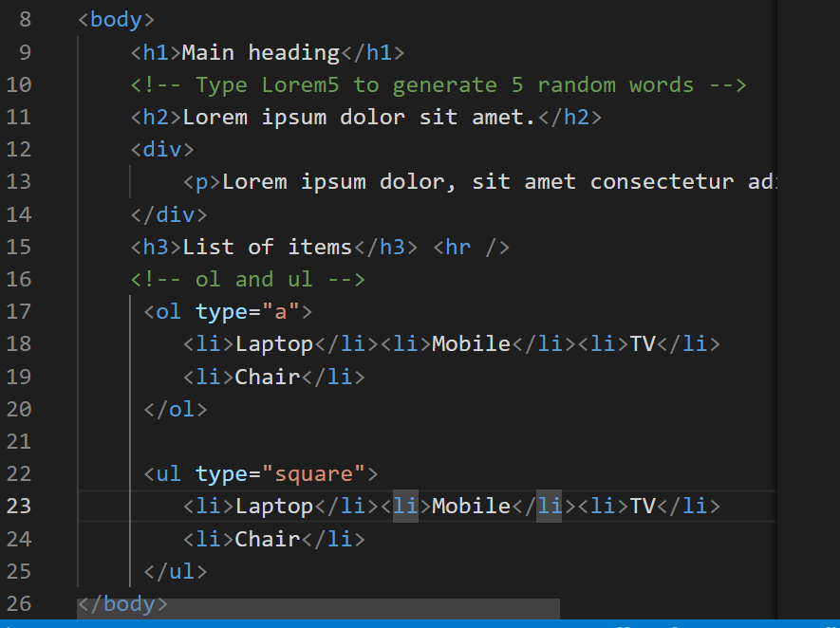

Output:

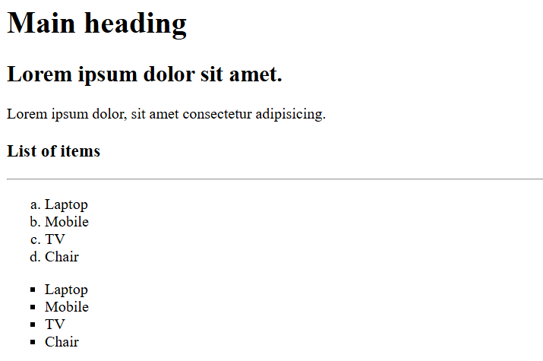

You can create HTML tables, forms and other elements

CSS:

It is used mainly to add the styles to HTML elements

RWD

It helps to fit your web page to all types of devices it could be desktop, mobiles, printing devices, tablets

Same HTML content to render differently in different devices

Medi Query: it applies the styles based on the conditions.